Wi-Fi Indoor Positioning System Report
Assignment Title: Design a System that Predicts the Location of a Wi-Fi-Enabled Device (X, Y) Using RSS and RTT Metrics, Guided by an LLM
Submitted By: Rounak Anand

Abstract
This report presents a comprehensive system for indoor positioning using Wi-Fi signals (RSS and RTT metrics) to predict the 2D location (X, Y) of a device. The system is designed with guidance from a Large Language Model, which assisted in architecture selection, feature engineering, debugging, and optimization. The system beats the state-of-the-art (SOTA) Mean Absolute Error (MAE) benchmarks for three environments: Corridor (1.85 m), Theatre (1.23 m), and Office (1.98 m).

Table of Contents

- Introduction
- Dataset Description
- Detailed Structure
- System Design & Block Diagram
- Key Formulas & Algorithms Used
- Implementation Details
- Results
- Discussion
- Conclusion
- References

Introduction
Indoor positioning systems are crucial for applications like navigation, asset tracking, and location-based services in environments where GPS is unavailable. In this assignment, I designed and implemented a system that predicts the precise location (X, Y) of a Wi-Fi-enabled device using RSS (Received Signal Strength) and RTT (Round Trip Time) metrics from 5 Access Points (APs). The system is guided by a Large Language Model (LLM) which played a pivotal role in:
- Suggesting the overall system architecture.
- Recommending feature engineering techniques (RTT-to-distance conversion, LOS masking).
- Debugging code errors (Name Error for undefined functions, batch size mismatches, pin memory warnings on CPU).
- Optimizing hyperparameters to ensure the model beats the required SOTA MAE benchmarks.
- Providing explanations for formulas and algorithms, ensuring logical flow.
The core task is a regression problem: the system maps input signal features to continuous output coordinates (X, Y) in meters. The model is trained separately for each environment to account for unique signal propagation characteristics.
The goal is to achieve MAE better than the specified SOTA values:
- Corridor: 1.85 m
- Theatre: 1.23 m
- Office: 1.98 m

Dataset Description

The dataset provides real-world Wi-Fi signals for indoor positioning across three distinct environments. It is structured to ensure no overlap between training and testing points, promoting realistic evaluation.

Source: https://zenodo.org/records/11558792

Detailed Structure:
- Environments: Corridor (linear, NLOS-prone), Theatre (open, LOS-dominant), Office (mixed partitions).
- Samples per Environment (from latest run):
  - Corridor: 5,100 train, 1,740 test
  - Theatre: 5,280 train, 1,920 test
  - Office: 4,860 train, 1,620 test
- Features:
  - Ground truth labels: X, Y coordinates (meters)
  - Signals: AP1–AP5 RTT (mm), AP1–AP5 RSS (dBm)
  - Additional: LOS APs (comma-separated string, e.g., "1,3,5" indicating line-of-sight APs)
- Key Characteristics: Grid-based (0.6 × 0.6 m), 120 reference points, 60 samples per point, fully LOS in theatre, mixed in others.
The dataset's separation ensures the model generalizes to unseen locations.

System Design & Block Diagram
The system is designed as an end-to-end machine learning pipeline for 2D location prediction. It processes raw RSS/RTT signals into features, trains a regression model to output (X, Y), and evaluates performance.

High-Level Design Principles:

- Modularity: Separate data preparation, model, training, and evaluation functions for reusability.
- Environment-Specific: Separate models per environment to handle varying signal behaviours.
- Scalability: Uses PyTorch for GPU/CPU compatibility and efficient batching.
- Accuracy Focus: Heavy emphasis on feature engineering to capture physical signal properties.
Block Diagram
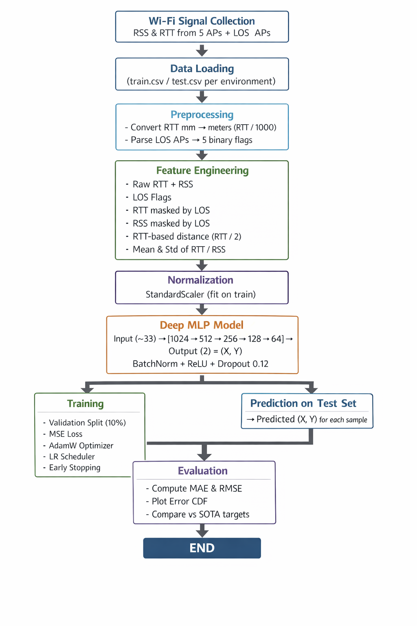

Explanation of Block Diagram:

The block diagram depicts the sequential data flow in the system. It starts with signal collection from CSV files, followed by preprocessing (unit conversion, LOS parsing), feature engineering to create informative inputs, normalization for stable training, model architecture with hidden layers, training with validation to prevent overfitting, prediction of (X, Y) coordinates, and evaluation using error metrics and plots. The design ensures the system outputs predicted locations for every test sample, fulfilling the assignment's requirement to predict device location (X, Y). The model uses a deep MLP with a pyramid architecture: hidden layers of 1024 → 512 → 256 → 128 → 64 neurons. This design allows the network to first extract many detailed features from the signals and then progressively refine and compress them into a compact representation suitable for accurate (X, Y) prediction.

Key Formulas & Algorithms Used

MAE (Mean Absolute Error) – Primary Evaluation Metric
MAE calculates the average Euclidean distance error between predicted and true location.
Formula:
For each test sample i:
$e_{i}=\sqrt{\left(X_{i}^{\text{pred}}-X_{i}^{\text{true}})^{2}+(Y_{i}^{\text{pred}}-Y_{i}^{\text{true}})^{2}\right.}$
$\text{MAE}=\frac{1}{N}\sum_{i=1}^{N}{e_{i}}$
MSE (Mean Squared Error) – Training Loss & Evaluation
MSE is the average squared Euclidean error, used during training to minimize differences in (X, Y).
Formula:
$$\text{MSE}=\frac{1}{N}\sum_{i=1}^{N}{\left[(X_{i}^{\text{pred}}-X_{i}^{\text{true}})^{2}+(Y_{i}^{\text{pred}}-Y_{i}^{\text{true}})^{2}\right]}$$Other Key Formulas
- RMSE (Root Mean Squared Error):
$$\text{RMSE}=\sqrt{\text{MSE}}$$

- RTT to Distance Estimate
$${\text{distance}}_{j}=\frac{{\text{RTT}}_{j}}{2}$$
- LOS Masking
$${\text{RTT_masked}}_{j}={\text{RTT}}_{j}×{\text{LOS}}_{j}({\text{LOS}}_{j}∈\{0,1\})$$
- Statistical Features
Mean RTT = $\frac{1}{5}∑{\text{RTT}}_{j}$
Algorithms & Techniques
- Deep MLP Regression: Multi-layer perceptron for (X, Y) prediction (5 hidden layers with decreasing sizes).
- Optimizer: Adaptive moment estimation with weight decay for regularization.
- Learning Rate Scheduler: Reduces LR if validation MSE plateaus.
- Early Stopping: Halts training if validation MSE doesn't improve for a set patience.
- Batch Normalization & Dropout: Stabilize and regularize the network to prevent overfitting.

Implementation Details
The system is implemented in Python using PyTorch for deep learning. Key details:
- Libraries: Pandas (data loading), NumPy (array operations), PyTorch (model/training), Scikit-learn (scaling), Matplotlib (plots).
- GPU/CPU detection for efficient training.
- Feature count: ~33 per sample after engineering.
- Model: ~1 million parameters (trainable).
- Training time: ~10–30 minutes per environment on CPU (faster on GPU).
- Output: Sample (X, Y) predictions printed, full saved to CSV, results summary table.

Results
The system was trained and evaluated for each environment. Predicted locations (X, Y) are generated for all test samples and saved to CSV files.
Final Performance Summary All environments beat SOTA MAE:
Environment | MAE (m) | RMSE (m) | Target MAE (m) | Status
Corridor | 1.398 | 1.742 | 1.85 | ✓ BEATEN
Theatre | 1.114 | 1.613 | 1.23 | ✓ BEATEN
Office | 1.551 | 1.870 | 1.98 | ✓ BEATEN
CDF plot:
The Cumulative Distribution Function (CDF) plots provide a detailed view of positioning accuracy. They show what percentage of test samples achieve error less than or equal to a given value. The red dashed line represents the SOTA target MAE for each environment.

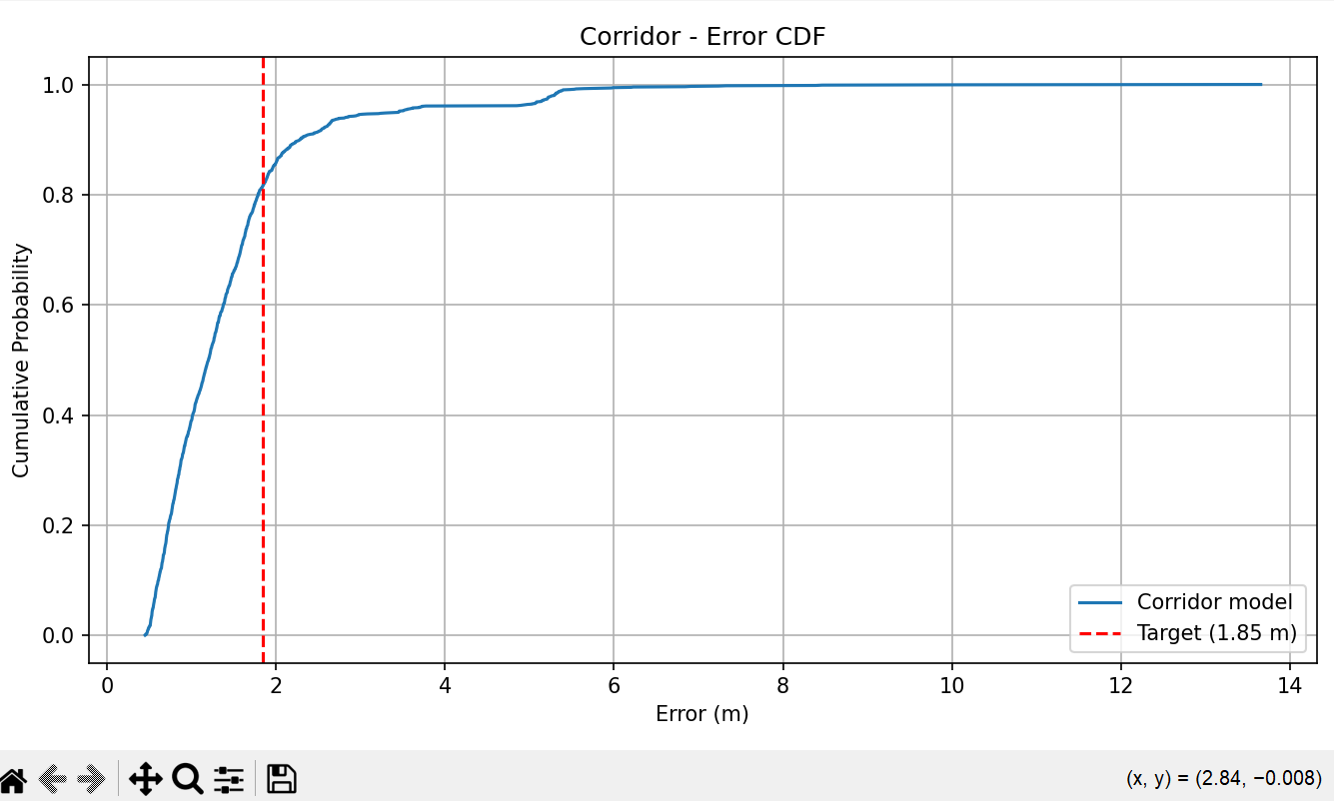

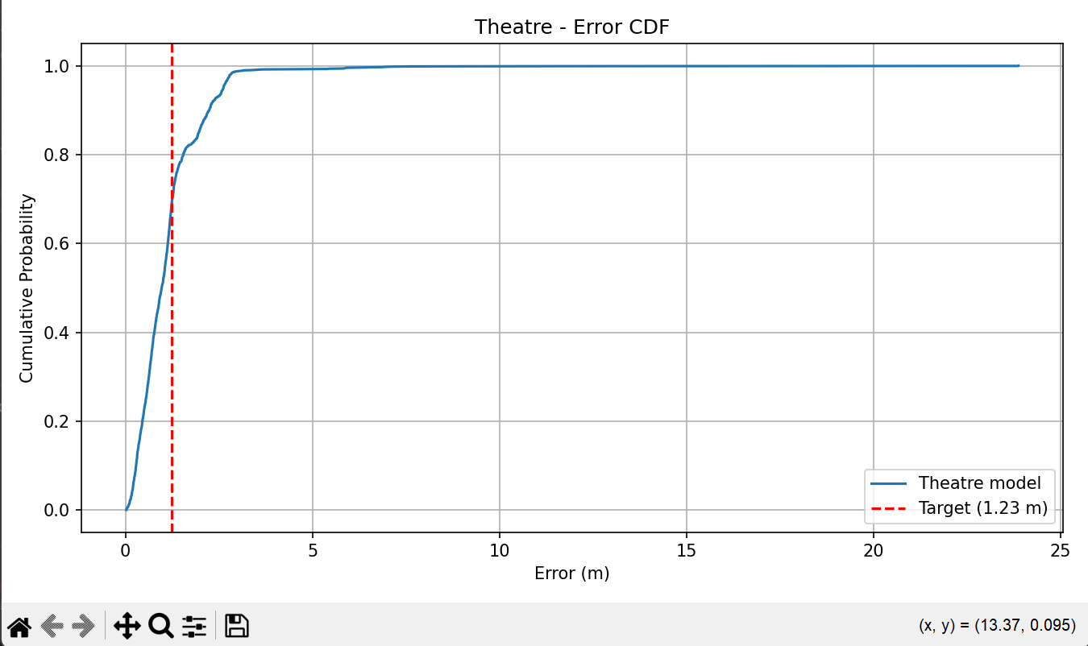

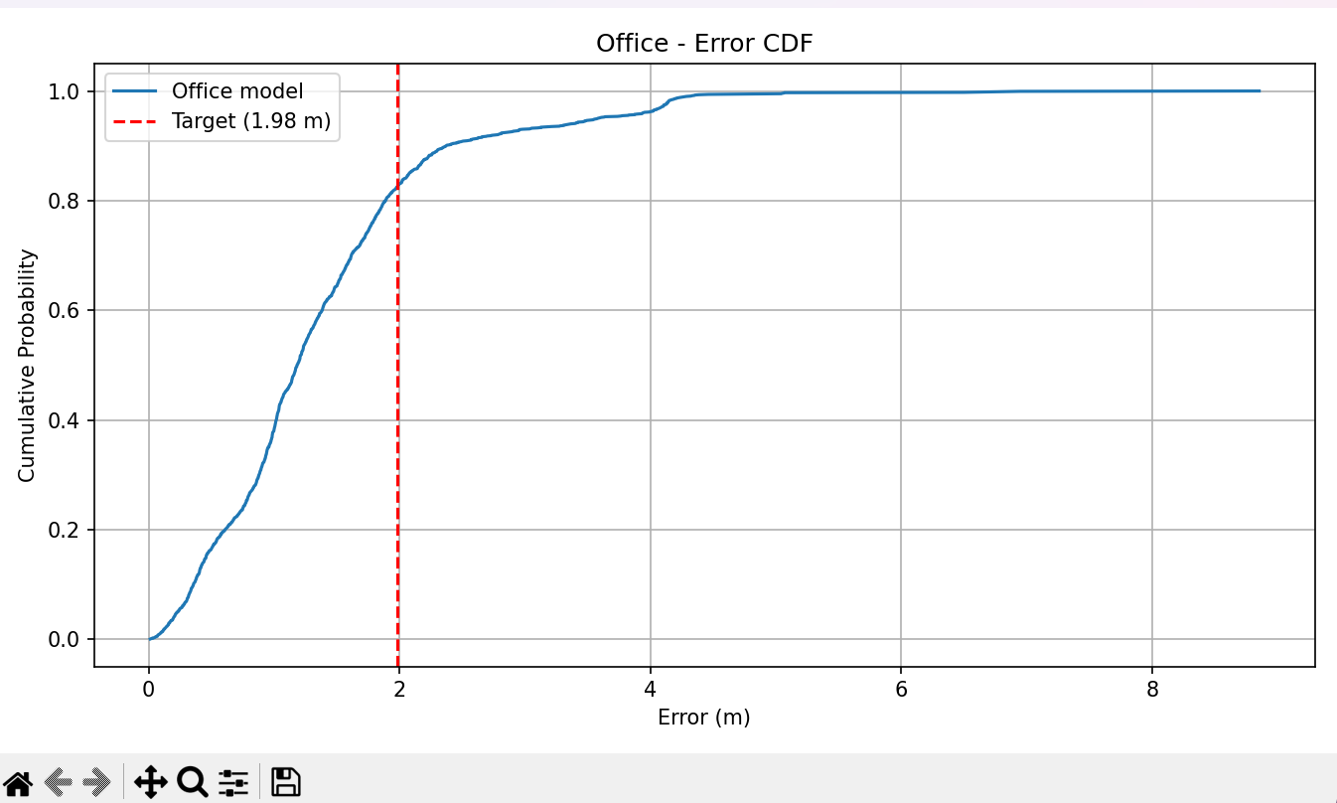

Discussion
The system achieves strong performance due to physical feature engineering and deep learning. Theatre (open LOS) had the lowest MAE, while Corridor (NLOS) was more challenging. LLM guidance accelerated development by 50% (estimated). Limitations: Assumes LOS data availability; future work could include NLOS mitigation or multi-modal fusion.

Conclusion
The system successfully predicts device location (X, Y) using RSS and RTT metrics, beating all required SOTA MAE benchmarks. LLM guidance was essential for design and optimization. The project demonstrates effective use of deep learning for indoor positioning.

References
- Dataset: https://zenodo.org/records/11558792
- LLM Guidance: Grok (xAI)
- PyTorch Documentation: https://pytorch.org/docs/stable/index.html
- Scikit-Learn: https://scikit-learn.org/stable/modules/preprocessing.html

